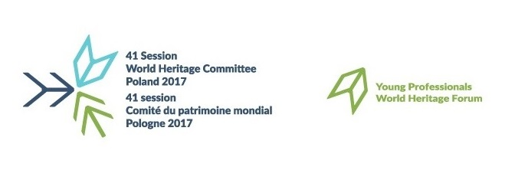
World Heritage Young Professionals Forum 2017 Declaration

We, the participants of the UNESCO World Heritage Young Professionals Forum 2017 “Memory: Lost and Recovered Heritage”, would like to express our gratitude to the President of the Polish National Commission, Professor Dr. Jacek Purchla, Chairperson of the 41st session of the World Heritage Committee and Dr. Mechtild Rössler, Director of the UNESCO World Heritage Centre. We would also like to thank the Polish National Commission for UNESCO and the International Cultural Centre in Krakow for organizing the Forum, and the Ministry of Culture and National Heritage of the Republic of Poland for the financial support. Furthermore, our special thanks go to the executive team and the groups of experts for their outstanding and relentless efforts.
Emphasizing the fundamental value of universal peace, enshrined in the constitution of UNESCO from 1945, and noting the UN Sustainable Development Goals, especially goals 11 and 16, we express our strongest concern about the destruction of heritage. We believe in the importance of joint efforts in protecting the heritage of Outstanding Universal Value and for developing sustainable societies;

Highlighting the mnemonic potential of World Heritage and firmly believing that memory sites are tangible evidence of cultural significance, in our turbulent world;
Convinced that preserving the identity of a property requires respecting the multitude of evolving ideas, values, practices, and perspectives relating to its history;

Remembering that without people there is no community and without memory, there is no possibility for sustainable development, it should be a duty of every State Party to put people in the centre of its Sustainable Development Goals;

Stressing that the opinion of local communities, indigenous peoples, artisans and youth should be an important factor when deciding on the conservation or reconstruction of cultural heritage;

Acknowledging cultural diversity and the importance of heritage sites for the respective local communities, their involvement in any decision about recovery, reconstruction and further use of heritage sites is of crucial importance, it is imperative to base the reconstruction of what is lost, in the community’s present sense of belonging.

Further stressing the importance of relying on the authentic sources, in order to avoid the appropriation of memory for political interests or “aggressive nationalism” there should be limits to reconstruction, primum non nocere (first, do no harm), based on the existing values of the communities;

Recalling that memory is dynamic, therefore space may be made for the new memories of future generations.

We, young professionals, as custodians of World Heritage, are strongly committed to our intergenerational and transnational responsibility of preserving World Heritage. We call on:

I. UNESCO:
as guardians of the Heritage Conventions, to consider promoting an integrated approach to safeguarding and recovery, preparedness and resilience combining tangible and intangible heritage, culture and nature;
in welcoming the efforts to include civil society and indigenous peoples into discussions and processes of the 1972 Convention, to further strengthen these efforts, especially concerning the inclusion of Youth.
II. International community:
to make local communities the keystone of any decision-making process relating to discussions on cultural identity and memory, as well as post-disaster management.

III. States Parties:

to protect heritage shared across borders, among others, by prioritizing transnational serial nominations and itineraries to the World Heritage List, to facilitate the bridging of cultures, local communities and nations;
to facilitate innovation, public-private partnerships, entrepreneurship, for sustainable recovery processes through creating conducive conditions for lean management and green energy and facilitating Youth employability in the field of heritage;

to implement educational activities and establish participation mechanisms for local communities, with a special attention to minorities, indigenous peoples, marginalized groups, people with disabilities, and Youth.
To support these efforts we, the participants of the Young Professionals Forum, 2017 commit ourselves:

to use the tools and innovations of our generation to maximize our potential and efforts, in the spirit of international solidarity and cooperation, equality and mutual respect;

to actively take part in discussions about social/collective memory in order to transmit cultural values to preserve our cultural diversity and to take on the responsibility to constantly reflect on the values of our heritage considering current and future contexts;
to be, in view of current events, a driver of peace, intercultural tolerance and international dialogue and to oppose any form of political, cultural or other extremism against people and their natural and cultural: tangible and intangible heritage.

Dziękujemy!

2 July 2017

